CALL FOR BOARD NOMINATIONS
In accordance with the BHBIA Articles of Association section 8.19, I am writing to inform you that the terms of office of seven Board Members (four industry division and three Agencies & Consultancies Division) will end at the Annual General Meeting in May 2024. Rob Heathcote and Ben Walker have notified the Board that they wish to stand down from the Board. However Rachel Dixon, Bors Hulesch, Paul O’Nions and Kelly West have notified the Board that they wish to be eligible for re-nomination and re-election and as a co-opted Board members Adesola Fadiora has notified the Board that she wishes to be eligible for nomination and election.
In accordance with the BHBIA Articles of Association section 8.3, the Board are seeking nominations for the four Industry Division and three Agencies & Consultancies Division Board Member places. Nominees must be proposed by a member of the BHBIA and seconded by a member from a different member company. Nominations must be received by BHBIA (at the address below) by 31st January 2024. If there are more nominees than places available, a ballot will be held in February 2024. Newly elected or returning Board Members will take up their position on the Board after the Annual General Meeting in May 2024 and their term will last for two years.
8. ELECTION OF BOARD MEMBERS
8.3 Each Member of the Corporate (Industry), Corporate (Agency/Consultancy) and Personal Membership categories shall be entitled to nominate only one person as a candidate for Membership of the Board. Every nomination will be required to be seconded by another Member of the Company.
8.8 Should more than five persons be nominated for Membership of each Division of the Board, the papers necessary for a ballot shall be despatched to Members as soon as possible after 31st January.
8.19 After their term of office the Chairman and Members of the Board (including co-opted Members) shall stand down but shall be eligible for re-nomination and re-election (or nomination and election, in the case of co-opted Members) to the Board.
Nominee | Proposed by  (name and company) | Seconded by  (name and company)
Nomination forms to be sent to BHBIA, St James House, Vicar Lane, Sheffield S1 2EX or scan and email to admin@bhbia.org.uk by 31st January 2024.
If you would like to know more about being a Board Member and what the role involves, please view an outline of the role on the website or do contact any Board Member.
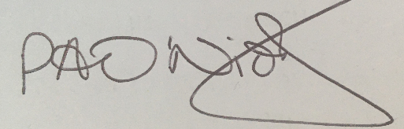
Paul O’Nions
BHBIA Chair

