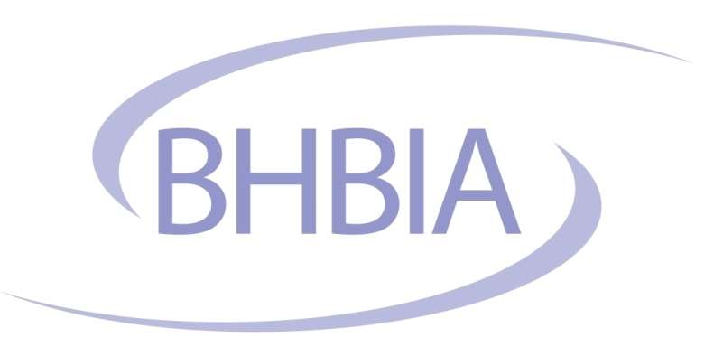

CALL FOR BOARD NOMINATIONS

In accordance with the BHBIA Articles of Association section 8.19, I am writing to inform you that the terms of office of four Board Members (three industry division and one Agencies & Consultancies Division) will end at the Annual Conference in May 2019. Sarah Morley has notified the Board that she wishes to stand down from the Board. However Dan Coffin, Nick Coolican Smith and Jenny Dawson have notified the Board that they wish to be eligible for re-nomination and re-election.

In accordance with the BHBIA Constitution section 8.3, the Board are seeking nominations for the three Industry Division and one Agencies & Consultancies Division Board Member places. Nominees must be proposed by a member of the BHBIA and seconded by a different member company of the BHBIA. Nominations must be received by BHBIA (at the address below) by 31st January 2019. If there are more nominees than places available, a postal ballot will be held in February 2019. Newly elected or returning Board Members will take up their position on the Board after the Annual Conference in May 2019 and their term will last for two years.

8. ELECTION OF BOARD MEMBERS
8.3 Each Member of the Corporate (Industry), Corporate (Agency/Consultancy) and Personal Membership categories shall be entitled to nominate only one person as a candidate for Membership of the Board. Every nomination will be required to be seconded by another Member of the Company.
8.8 Should more than five persons be nominated for Membership of each Division of the Board, the papers necessary for a ballot shall be despatched to Members as soon as possible after 31st January.

8.19 After their term of office the Chairman and Members of the Board (including co-opted Members) shall stand down but shall be eligible for re-nomination and re-election (or nomination and election, in the case of co-opted Members) to the Board.

Nominee | Proposed by  (name and company) | Seconded by  (name and company)

Nomination forms to be sent to BHBIA, Ground Floor, 4 Victoria Square, St. Albans, Hertfordshire, AL1 3TF or scan and email to admin@bhbia.org.uk by 31st January 2019.

If you would like to know more about being a Board Member and what the role involves, please view an outline of the role on the website or do contact any Board Member.

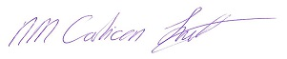
Nick Coolican-Smith

BHBIA Chair

